Unit 10 Section A
(20分钟 50分)
Ⅰ. 根据句意及图片或首字母提示完成单词（3分钟，5分）

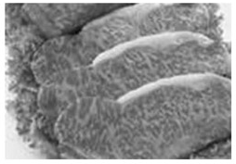
1. We have ______ noodles.

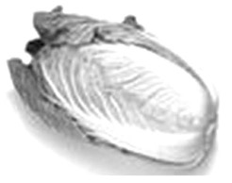
2. I like Chinese ______.

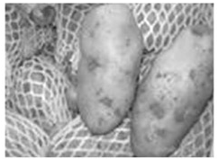
3. The ______ come from
Ningxia.

4. The shirt is too small. Can you give me a l______ one?
5. There are many kinds of d______ in the supermarket, like coke, sprite and tea.
Ⅱ. 用所给词的适当形式填空(3分钟，5分)
1. She eats ______ (tomato) every day.
2. We’d like ______(go) out for a walk.
3. Beef and potatoes, mutton soup(汤) are their ______(special).
4. —What ______(will) you like? —Apples.
5. They’d like three bowls of mutton and ______(potato) noodles.
Ⅲ. 单项选择(3分钟，10分)
（ ）1. I’d like some ______.
A. beef B. potato C. noodle D. bowl
（ ）2. —Would you like some milk?
—______ .
A. Yes, I would B. No, I wouldn’t
C. Yes, please D. Thanks
（ ）3. — What ______ noodles would you like?
— A medium one, please.
A. kind of B. kinds of
C. size bowl of D. sizes bowl of
（ ）4. —What size shirt would you like?
—A _______ one.
A. red B. large C. big D. long
（ ）5. —What would you like?
—______
A. Some drinks, please. B. I like drinks.
C. I’m tall and thin. D. Sorry, I don’t know.
Ⅳ. 完成句子(3分钟，10分)
1. I’d like tomato and mutton noodles. (就划线部分提问)
______ ______ ______ noodles would you like?
2. Mary would like a small bag of fruit. (就划线部分提问)
______ ______ ______ of fruit would Mary like?
3. She’d like a story book. (改为一般疑问句)
_____ she ______ a story book?
4. Kate would like something to eat. (改为同义句)
Kate ______ something to eat.
5. 你们有多大号的？
______ ______ do you have?
Ⅴ. 看图补全对话，每空一词(4分钟，10分)
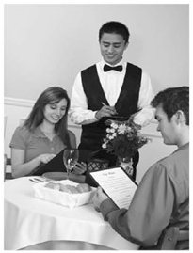
A: Can I help you?
B: OK, I’d 1 some soup（汤）, please.
A: What 2 of soup would you like?
B: I’d like egg and tomato soup.
A: Well, what 3 bowl of soup would you like?
B: What sizes do you have?
A: We have 4 , medium and small bowls.
B: Oh, a medium 5 , please.
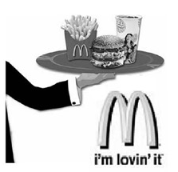
1._____ 2._____ 3._____ 4._____ 5._____
Ⅵ. 阅读理解(4分钟，10分)
Do you know MacDonald? It is a large fast food restaurant. Would you like to eat the best(最好的) hamburgers and other specials? Macdonald is a good place to enjoy them.
In Macdonald, there are many kinds of hamburgers, like beef hamburgers, cheese hamburgers, chicken hamburgers, rice hamburgers and egg hamburgers.
It also has other specials. If you like, you can taste(品尝)French fries, salad and fruit pies.
As for drinks, it has coke, sprite, orange juice, ice tea, hot tea, hot coffee, and milk shake(奶昔). It has large, medium and small glasses(杯)of drinks. Sometimes, the drink is free(免费的).
任务一 根据短文内容，完成句子
1. Macdonald is a __________________________.
2. Macdonald is the best place to eat ___________.
任务二 判断正(T)误(F)
( )3. Macdonald has many kinds of hamburgers.
( )4. The price of the drinks in Macdonald is high.
任务三 把下划线句子翻译成汉语
5. __________________________________________________________

答案解析
Ⅰ. 答案：1. beef 2. cabbage 3. potatoes 4. large 5. drinks
Ⅱ. 答案：1. tomatoes 2. to go 3. specials 4. would 5. potato
Ⅲ. 答案：1~5. ACCBA
Ⅳ. 答案：1. What kind of 2. What size bag 3. Would; like
4. wants 5. What size(s)
Ⅴ. 答案：1. like 2. kind 3. size 4. large 5. bowl/one
Ⅵ. 答案：1. large fast food restaurant 2. hamburgers 3. T 4. F 5. 麦当劳有大杯、中杯和小杯饮料。

